Ipek Sayar

09/12/2024

Pd. 5

Journal #4

We’ve spent this week considering many of the small details we need to address before starting the project. Jacob and I want all our files to be shared, allowing us to either work on the same part or on different parts while helping each other as needed. We’ve basically decided to use GitHub so we both have access to everything at all times.

Last class, you suggested that we should have a front end for our project to present something at TJStar. Jacob and I discussed it and decided to create a mobile app where users can upload their pictures or videos and receive detailed feedback. For our final presentation, we plan to make a video ourselves, upload it, and demonstrate the feedback process. Jacob took on the task of researching how to build the app and he believes the easiest approach is to develop a native Android app using Kotlin, as it's modern and works well with Android Studio, which has a built-in emulator. He’s also exploring Jetpack Compose for the UI, as it seems easier than working with XML. We plan to create the interface together, so I’ll also learn how to use the software he chooses.

I emailed the creators of the VideoBadminton dataset last week, and we’re still waiting to hear back from them. We might need to find alternative data sources for our project. In the worst case, we may have to manually label different clips and classify shots like smashes, drops, and clears. Meanwhile, we're also thinking about adding multiple models for different playstyles, such as comparing the user’s style to Olympic teams from the U.S. or China or other well known teams.

Another important aspect is creating a system that provides meaningful feedback to users. The challenge is not just detecting errors but explaining them in a way that helps users improve their technique. We can’t simply say, “For your short serve, you had a 10% error to ‘perfect form.’” It has to be something more like, “You have a 10% error for your short serve. Here are some tips to improve it...” Once we identify what’s wrong with their form, we can generate images or videos to show what perfect form should look like.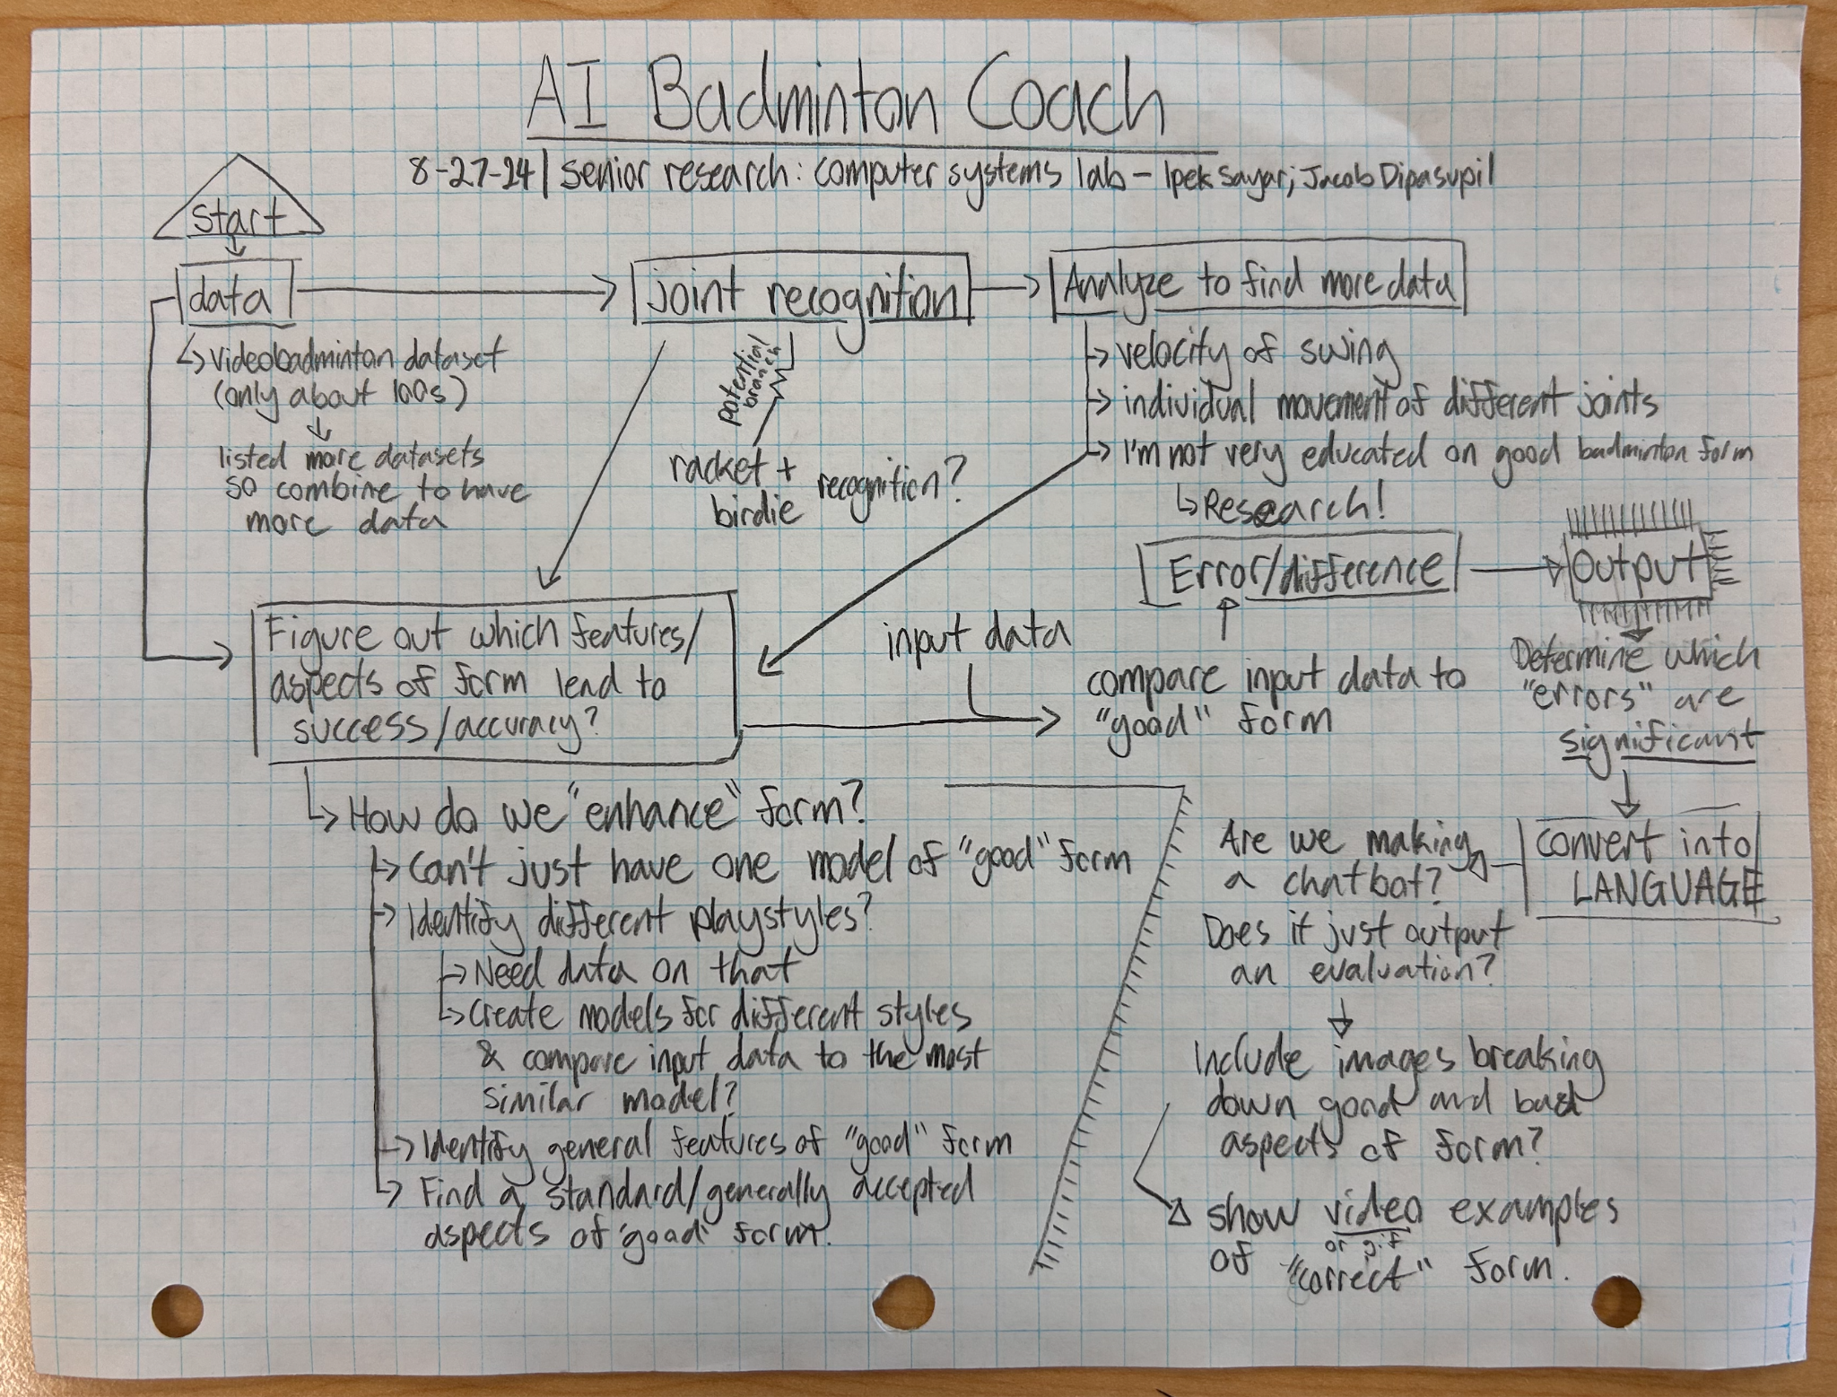

We’ve finished the project proposal, but I want to review and confirm some of my ideas with Jacob before submitting it. We also created a diagram to outline our progress moving forward. →